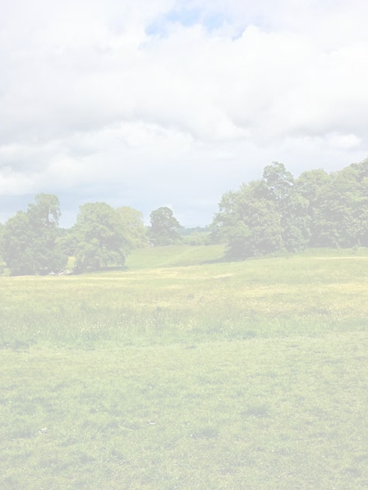



**Code of Conduct**

We want to ensure that everyone enjoys this space while respecting each other and the park’s natural environment. Here are some guidelines we’d like you to follow:

1. Everyone should be able to enjoy using this park, in the spirit of Winifred Jacob Smith’s wishes.
2. Please be kind and courteous to other park users and respect their right to use the park.
3. Let’s take care of the wildlife and be sensible - avoid climbing on fragile trees and walls, be safe around the water and please leave the wild flowers for others to enjoy.
4. Be aware that not every park visitor wants to interact with dogs off their leads; ensure that you can recall your dog but if not, please always keep your dog on a lead. Your dog should remain visible to you at all times and be kept away from any children playing.
5. If you’re a dog owner, your dog’s behaviour and clearing up their waste is your responsibility.
6. We recommend that one person should look after no more than four dogs at once.
7. Let’s all do our part to keep the park clean and tidy by taking any rubbish with us when we leave. If you see any unattended rubbish we would really appreciate you taking it with you.

**Thank you for being a responsible park user and helping us maintain a friendly and positive atmosphere here at Jacob Smith Park.**

**Enjoy your visit!**

